**Flex Container:** An element set to display: flex; becomes a flex container.

**Flex Items:** Children of a flex container become flex items.

**Flex Properties:**

**display:** flex; or display: inline-flex; (for inline-level containers).

**flex-direction:** Determines the main axis direction (row, row-reverse, column, column-reverse).

**flex-wrap:** Controls whether items wrap onto new lines (nowrap, wrap, wrap-reverse).

**flex-flow:** A shorthand property combining flex-direction and flex-wrap.

**justify-content:** Aligns items along the main axis (flex-start, flex-end, center, space-between, space-around).

**align-items:** Aligns items along the cross axis (flex-start, flex-end, center, baseline, stretch).

**align-content:** Distributes space when there's extra space in the cross axis (flex-start, flex-end, center, space-between, space-around, stretch).

**Flex Item Properties:**

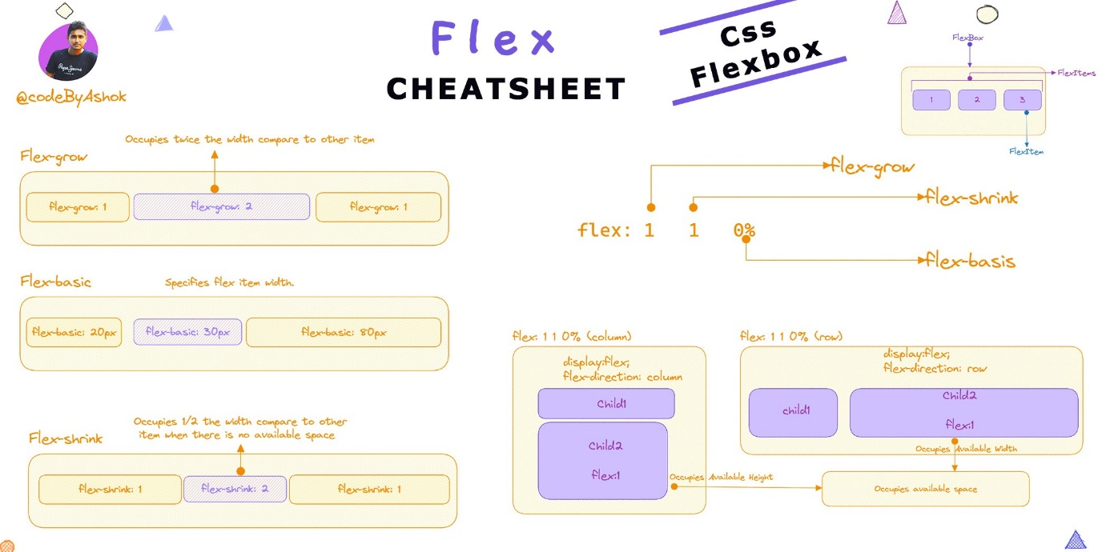

**order:** Controls the order in which items appear (integer value).

**flex-grow:** Specifies how items grow to fill available space.

**flex-shrink:** Specifies how items shrink when there's not enough space.

**flex-basis:** Sets the initial size of an item.

**flex:** A shorthand property for flex-grow, flex-shrink, and flex-basis.

**align-self:** Overrides align-items for a single item.